Fantasy Football Team Creator

Anthony Vo, Aishwariya Bhatt, Chen-Feng Huang, Ye

***Abstract***

Fantasy Football League is a competitive game that involves strategies, analysis, and predictions. In order to draft a team with the best potential, game participants must know who are the best players for each position, what is the optimal team composition, and who are most likely to improve this season. These analysis-heavy tasks are where machine learning algorithms can be applied. Our app helps Fantasy Football participants to draft the best roster by using machine learning algorithms to find the best player for each position. We use players’ statistical data from the past 3 years to predict how well a player is going to perform this year.

Keywords

Linear Regression, Flask, Predicted Score

1. Introduction

Fantasy Football is a game in which the participants serve as the general manager of a virtual football team. The participants choose their rosters by participating in a draft where all the players in real foot league are available. Points of the team are based on the actual performance of each player in the team in the real-world competition. The game requires an extended knowledge of each individual player as well as team composition. The game also requires multiple strategies, such as prioritize which position or which player in the draft. These tasks are very suitable for machine learning algorithms, and that is how our app gives an edge to our users over other fantasy football game participants.

1.1 Fantasy Football

Fantasy Football is a fantasy sport of the football played online by the participants where the play the football game virtually. The participants assemble imaginary or virtual teams of the real players which they like based on their previous records of the games. These teams are formed based on their previous statistical performance played during the actual earlier games.

After each participant have selected their teams, during the real National Football League (NFL) they compete with the other teams. The real teams of the NFL compete with each other and the players scores are converted to the points according to the criteria decided by the Fantasy Football. Using those points the Fantasy teams competes with each other in the league. During the NFL season, the real teams and the real player face each other and so does the fantasy teams in your Fantasy Football League. The players' real-time statistical data are converted into fantasy points by your league provider, and the fantasy team that scores the highest wins the game of the week.

1.2 Fantasy Football Team Creator:

Fantasy Football Team Creator helps the participants to select the best players for fantasy team. The participant uses the Fantasy Football Team Creator to see the generated team according to the different position played by the players. For Example Quarter Back (QB), Running Back(RB), Wide Receivers(WR), Tight End(TE), etc, are the various positions played by the players. Fantasy Football Team Creator provides the participants the best players for each position it then depends on the participants for which position which player does he want to lock in.

1.2.1 Generate Team:

The Participants when clicks on generate your team the get four best players for each position QB, RB, TE, WE. The player with the highest score predicted from the previous statistical data is recommended to the participants along with all other players sorted according to their points, one with highest at the top and one with least points at the last, so that the participants knows about the other players too. If the participant wants to lock another player then the recommended one they can select that too.

1.2.2 View Players:

The Participant can see the pool of all players participating in the National Football League along with all their details like their statistical data of the previous games which they have played during the earlier year games. The detail view of each player is given when they select a player and click on their image to view the details. The detail view show their statistical data of previous games, their performance graph from the previous year, their calculated points all each year they have played.

1.2.3 Admin:

The predicted score which are predicted for each player using linear regression are performed using the data of the player played in the previous game. The admin can also update the predicted statistics for any year which selected.

1. Methodolgy

On the frontend side, we based on a Bootstrap model, jumbotron, to create a prototype view of our HTML/CSS website pages. Later on, we applied “frosted glass effect” and other Bootstrap model to modified the website in order to let the website to form a new look we are expected.

On the backend side, Flask web framework. Flask web framework connects the frontend side and the backend side. The players data of all the games are stored in MYSQL database along with their predicted stats. The backend side interacts with the MYSQL database and provides the information at the front.

Prediction of Score:

Passing Yards: 1 point per 25 yards

Passing Touchdowns: 4 points

Passing Interceptions: -2 points

Rushing Yards: 1 point per 10 yards

Rushing Touchdowns: 6 points

Receptions: 1 points

Receiving Yards: 1 point per 10 yards

Receiving Touchdowns: 6 points

2-Point Conversions: 2 points

Fumbles Lost: -2 points

Fumble Recovered for a Touchdown: 6 points

1. Work Flow Diagram of the System:

Fantasy Football Team Creator is divided into three modules:

1. Generate Team
2. View Players
3. Admin

The flow of working is shown in Figure 3.1

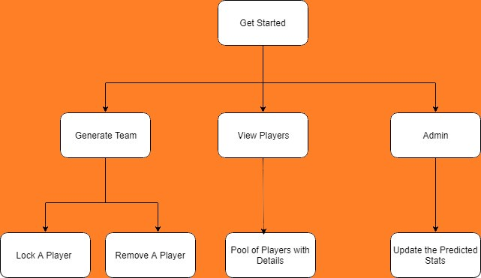

Fig 3.1 Fantasy Football Team Creator

1. Implementation

The participants can use the features of the system by clicking on get started as shown in Figure 4.1.

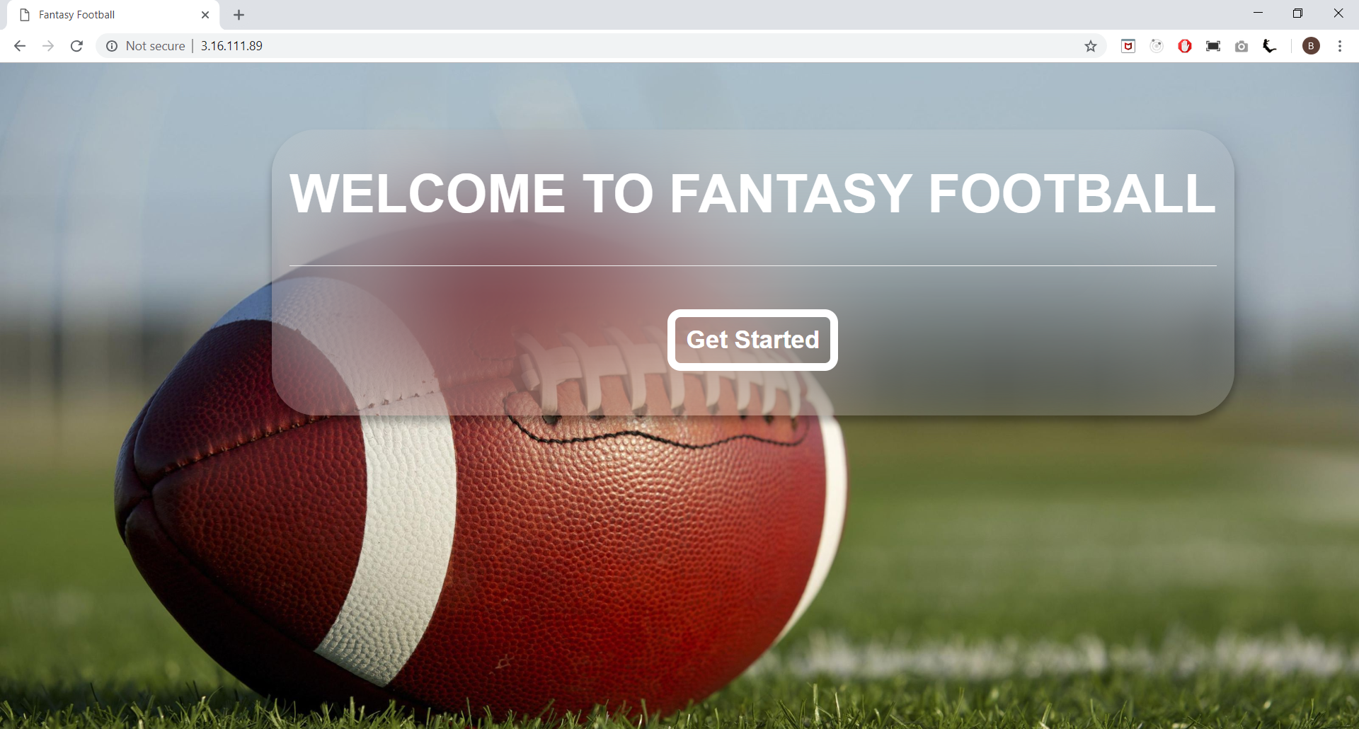

Figure 4.1 Fantasy Football Team Creator

After get started it takes the participant to the main page where they generate team.

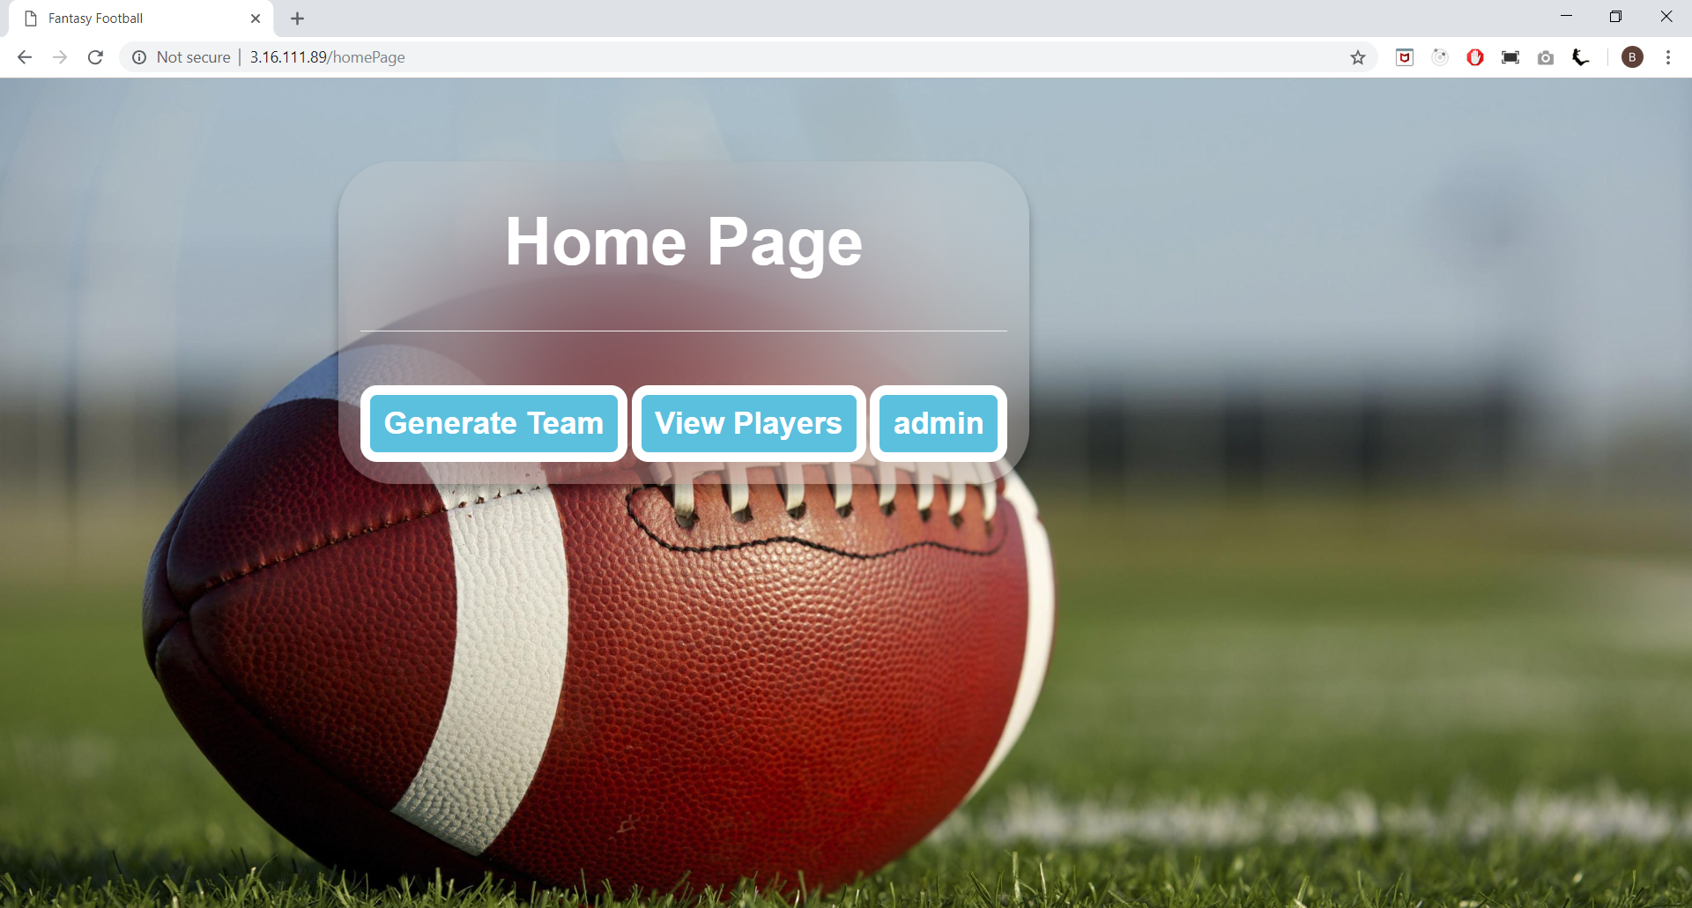

Figure 4.2 Home Page of the Fantasy Football Team Creator

Generate Your Team:

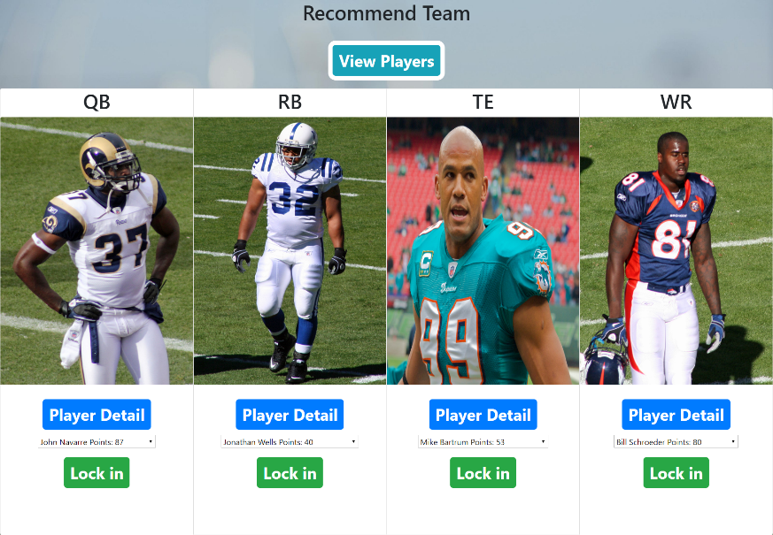

Figure 4.3 Showing best players for each position.

View Player Pool:

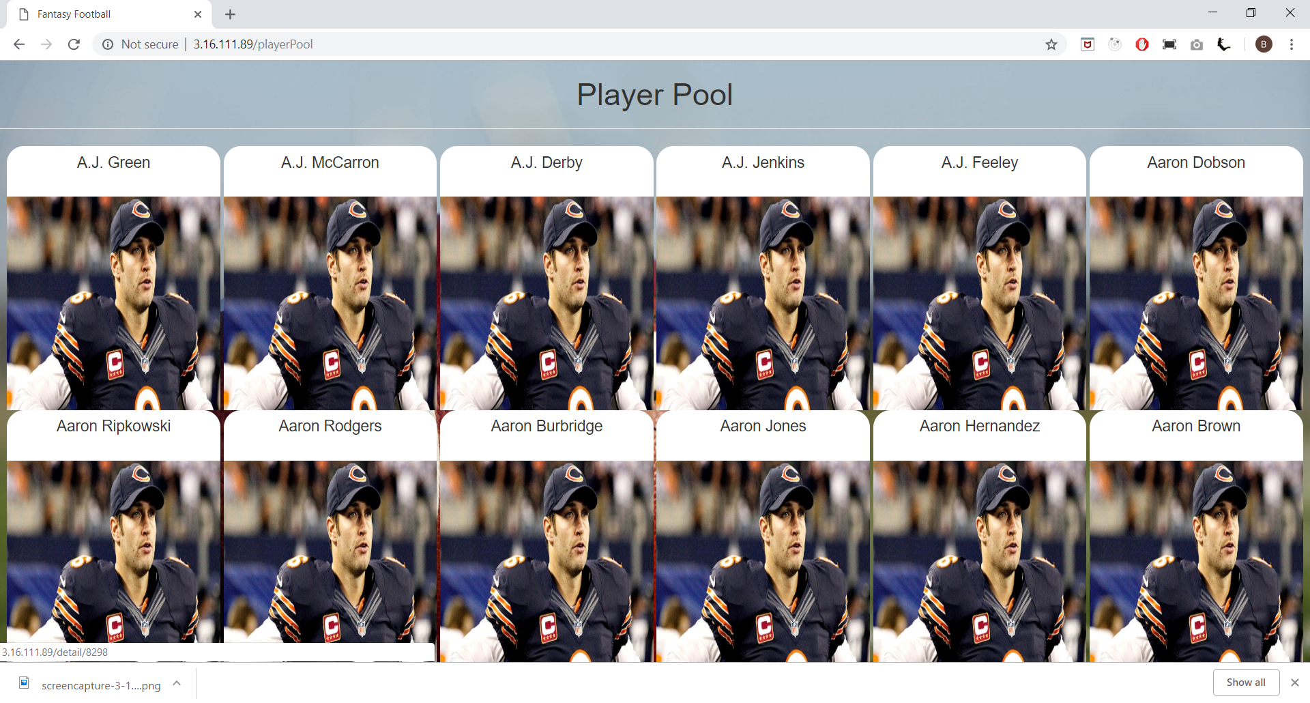

Figure 4.3 List of all player.

View Player details:

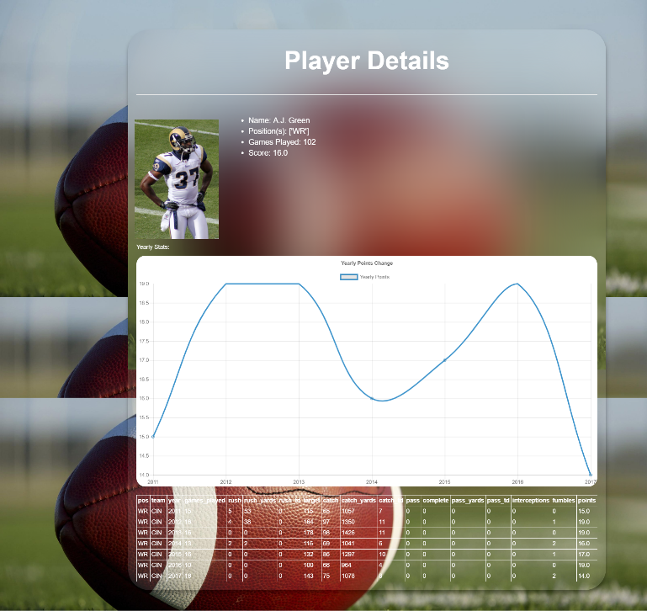

Figure 4.4 Player Details showing graph.

Player detail can also be seen on the recommended team page as shown in the Figure 4.5

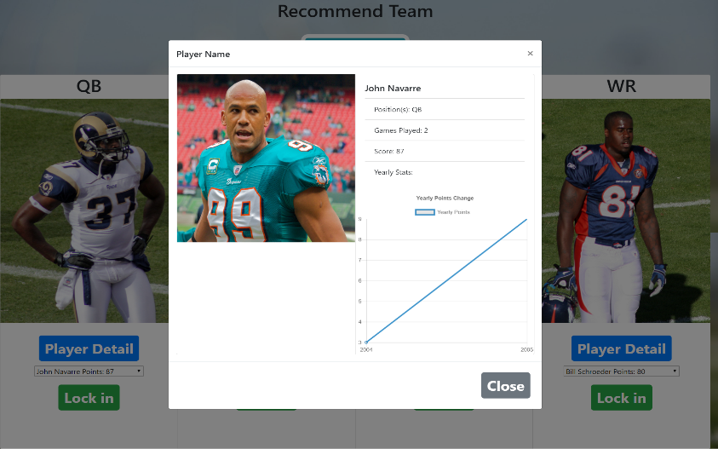

Figure 4.5 Detail of a Player

Saving a Player for your Team:

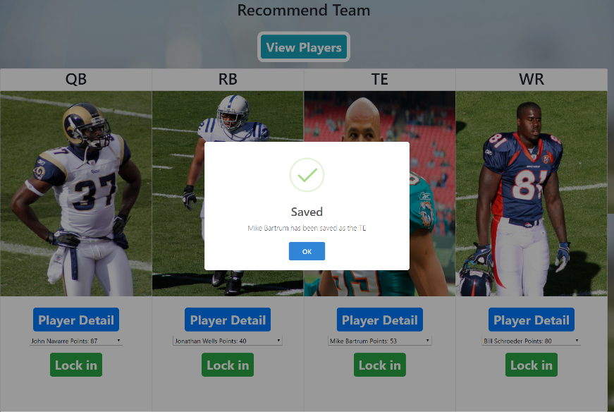

Figure 4.6 Save a Player

Locked player as shown in Figure 4.7

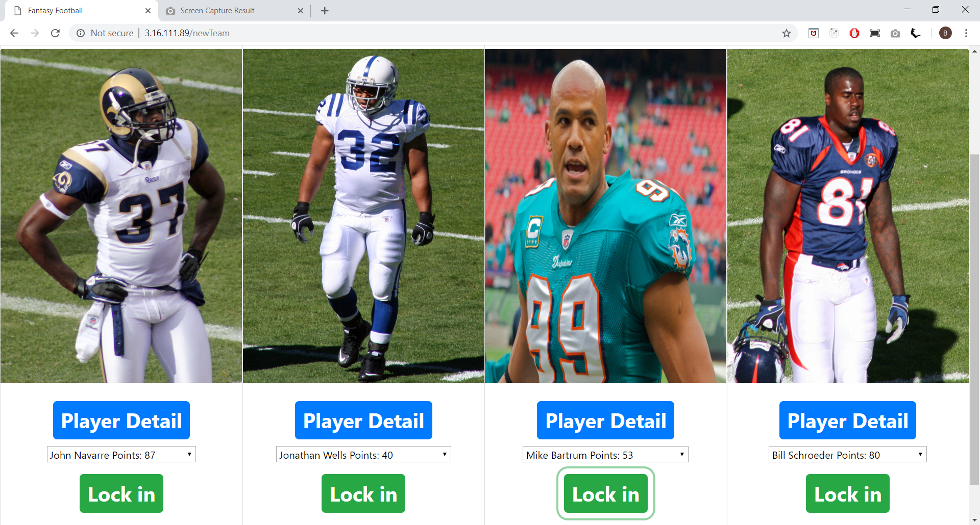

Figure 4.7 Locked Player for the team

Showing other player points for the same position as shown in Figure 4.8

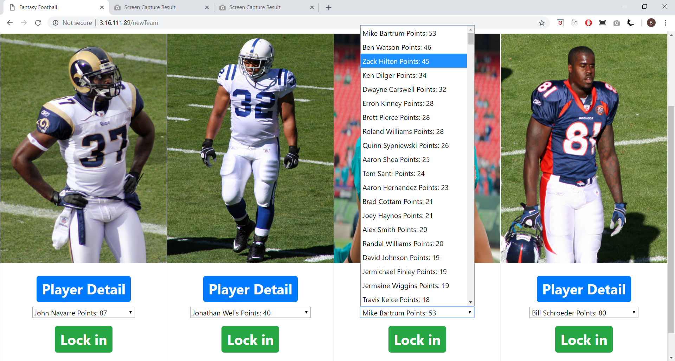

Figure 4.8 Showing other player points.

Admin updating the predicted statistical data:





1. Future Enhancement

* Password protected access for admin.
* Allow players to flag unavailable players from roster.

1. Conclusion

The system helps the participants to select the best players for his team as it provides information to the roster showing statistical data of each and every player, they can compare different player using those data. Using those result best players for the team are selected.

1. References
2. <http://thehuddle.com/fantasy_football_statistics_archive.php>
3. <https://protips.dickssportinggoods.com/sports-and-activities/football/football-101-football-positions-and-their-roles>
4. <https://www.nfl.com/>